Kingston XS1000 1TB External Solid State Drive SSD | USB-A 3.2 Gen 2 (CZONE)

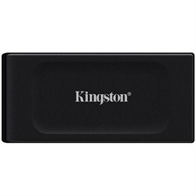

**Key Features**

* **1TB Storage Capacity**: With 1TB of storage, the XS1000 offers ample space for storing large files such as videos, photos, games, documents, and more. It’s an ideal solution for content creators, professionals, and gamers who need quick and reliable access to their data.
* **USB-A 3.2 Gen 2 Interface**: The XS1000 uses a USB-A 3.2 Gen 2 connection, offering transfer speeds of up to **1,000MB/s**. This makes it faster than traditional USB hard drives, providing a noticeable boost in performance when working with large files or during system backups.
* **Compact and Lightweight Design**: The XS1000 is designed to be ultra-portable, with a compact size that makes it easy to carry in a bag or even a pocket. It’s a great option for users who need to take their data on the go, whether traveling for work or on personal trips.

**Design and Build Quality**

* **Compact and Portable**: The XS1000 is incredibly small and lightweight, measuring just 90mm x 50mm x 12mm (approximately 3.5 x 2 x 0.5 inches) and weighing only 37g (about 1.3 ounces). Its size makes it extremely portable, allowing users to carry it easily in a laptop bag or pocket.

**Warranty and Support**

* **Limited 3-Year Warranty**: Kingston backs the XS1000 with a **3-year limited warranty**, offering peace of mind in case of any product defects or failure during normal usage.